**GreyCampus Free Fullstack Development Program**

1. Login using your Username and Password.

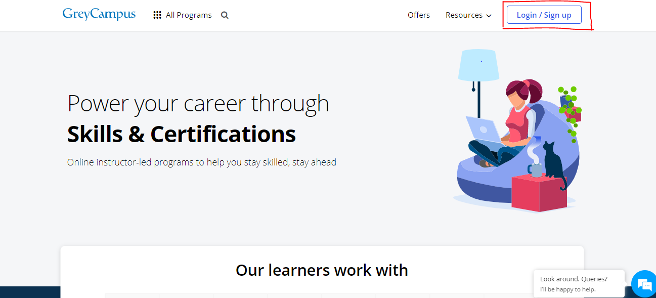

2. Under My Courses, select ‘Free Fullstack Development Program’ by clicking it.

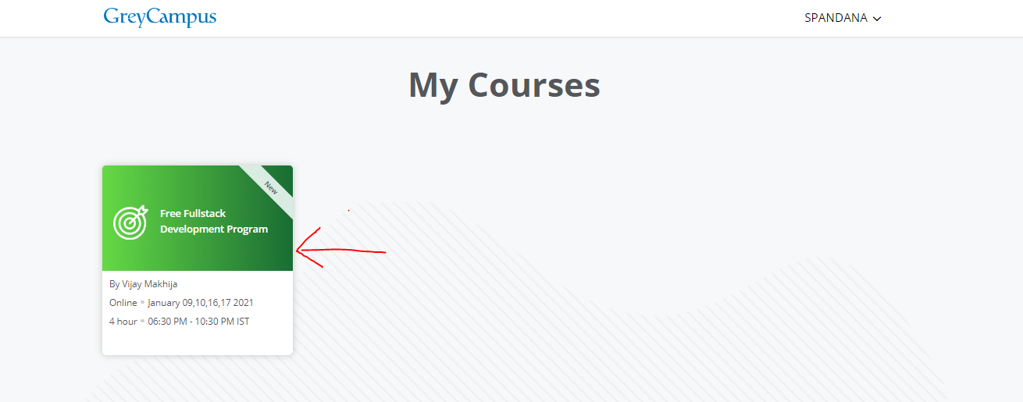

3. Once you are in, you will see a button on the top right side named 'Join Bootcamp' on the Dashboard. Click on the link to join us on Day 1 which is on 9th January at 8:00 AM EST (6:30 PM IST). We will walk you through the Dashboard and other required features during the Orientation, followed by the instructor-led session.

